**REST - Get country based on country code**

**Objective:**

To create a RESTful service in Spring Boot that:

* Accepts a country code in the URL (/countries/{code})
* Loads country list from country2.xml (Spring configuration file)
* Returns the matching country as JSON response

**1. Create the Spring Configuration File (country2.xml)**

This file contains a list of country beans.

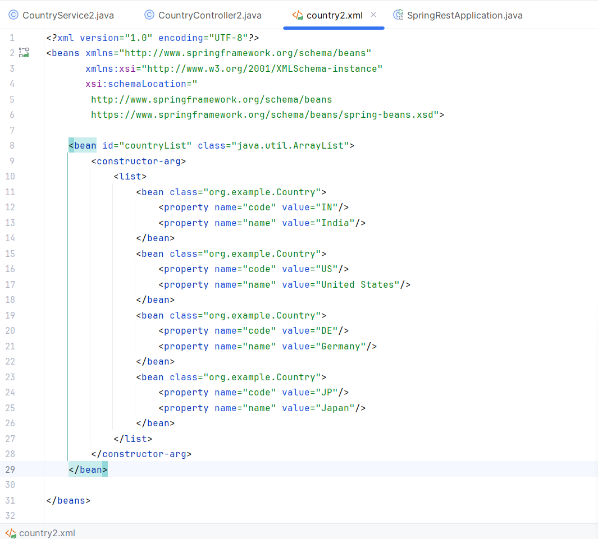

**2. Create the Country POJO Class**

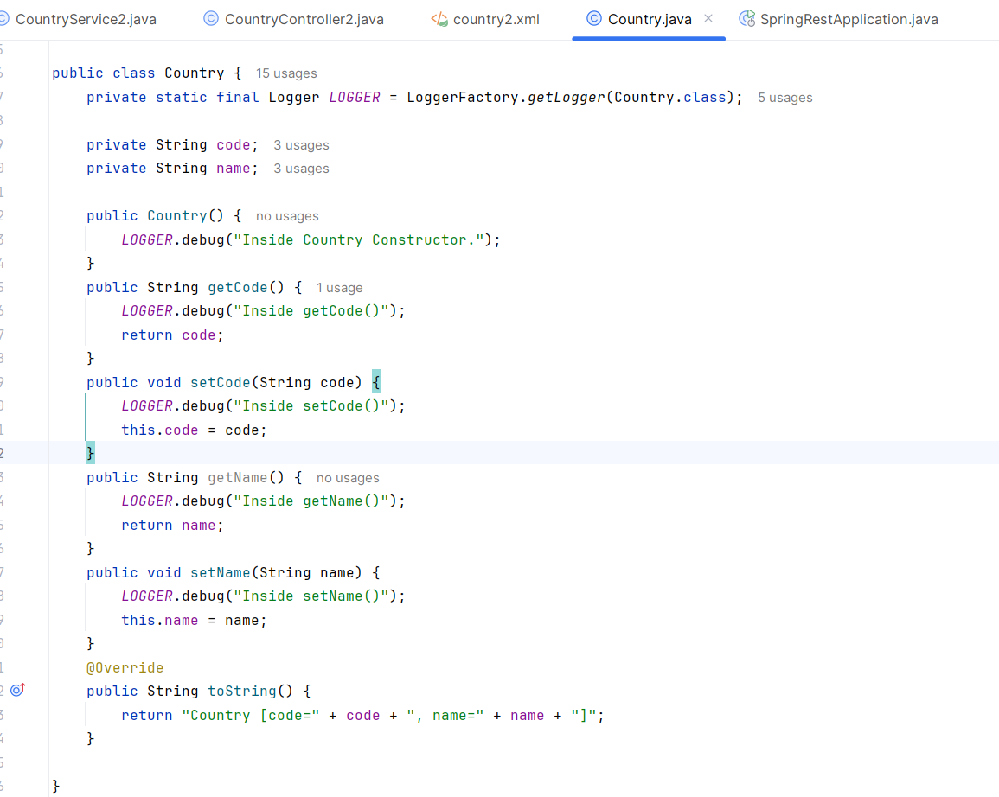

**3. Create Service Class: CountryService2.java**

This service loads countryList bean and returns a country by code (case-insensitive).

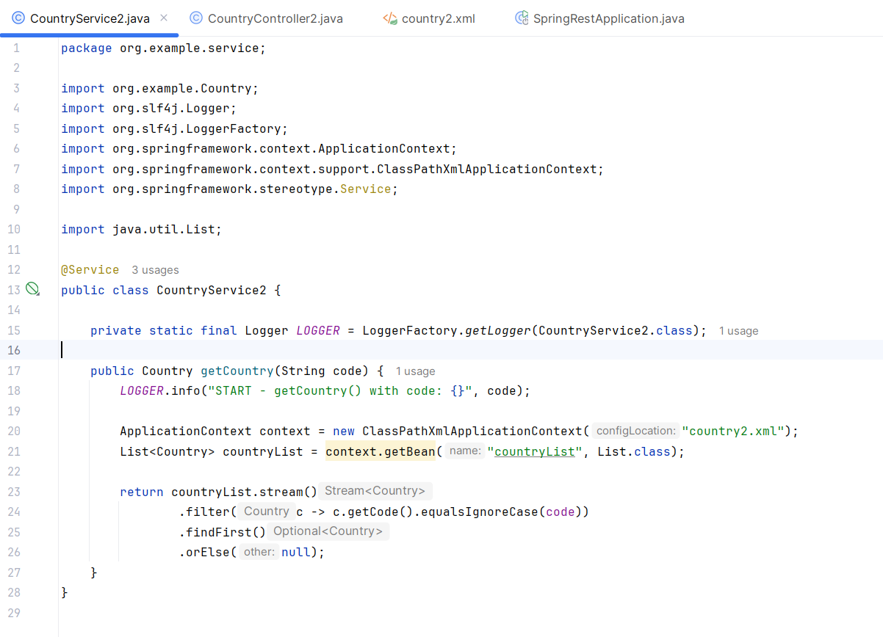

**4. Create Controller Class: CountryController2.java**

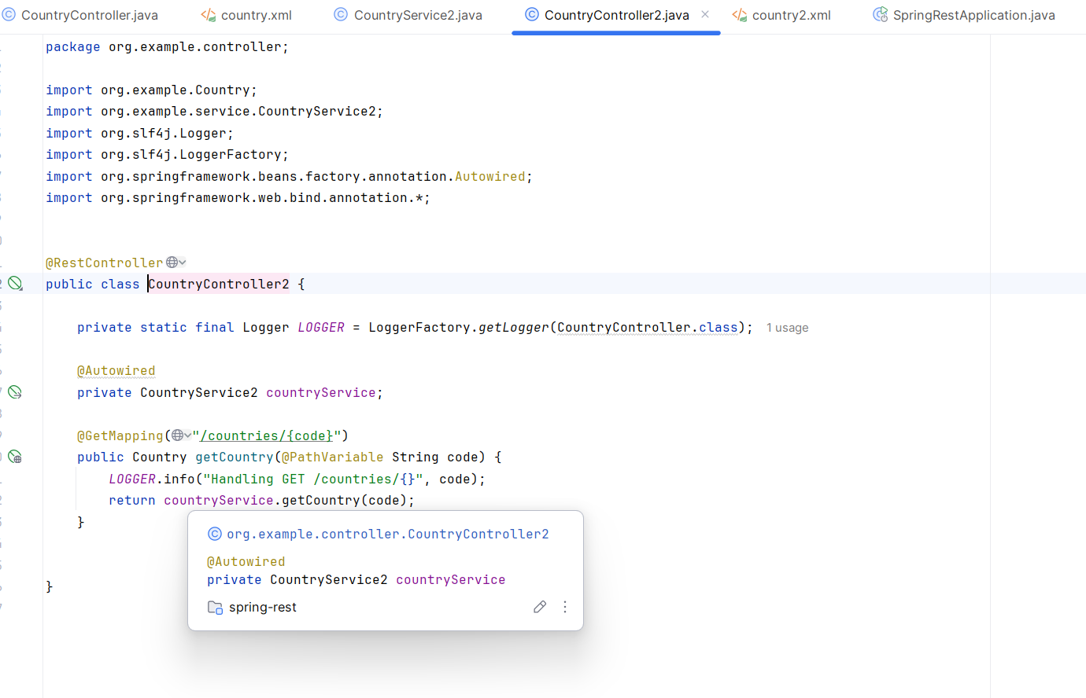

**5. Run the Application and Test**

